Understanding the Value of Adult Learning
Creating tailor-made learning environments / Omnia’s perspective

The dimensions of a learning environment as described by Ms Aaltonen in Espoo in September 2009

LEARNING
Cognition
Emotion
Environment

The focus of planning a learning environment should always be on the individual, the learner. It should always reflect his/her way of learning and take into account all former skills and competences he/she might already possess. In Omnia Adult Education Centre every student has his/her own individual study plan which makes the planning of learning environments even more difficult. Especially so, if learning environments are only seen in a traditional way. The meaning of distance and e-learning comes more and more important and this demands even greater skills from the teaching staff.

The range of learning environments in Omnia varies quite a bit. But still a majority of teaching takes place in traditional classrooms and teaching labs. The innovativeness of a learning environment is directly linked to teacher’s own motivation and interests. There are no accurate dimensions or guidelines set by the administration concerning learning environments.

The most important factor in choosing a specific environment or method for teaching, when trying to achieve the best possible learning outcomes, is the learning path of the individual learner. The individualisation plan gives the directives for the choices he/she can make and might also emphasize some learning methods (e.g. distance learning, on-the-job learning).

The most typical learning environments in Omnia are: classrooms, work labs, work placements, e-learning and other web based environments such as Moodle, WebEx, Skype, Wikispaces.

And finally, a different approach to learning environments.

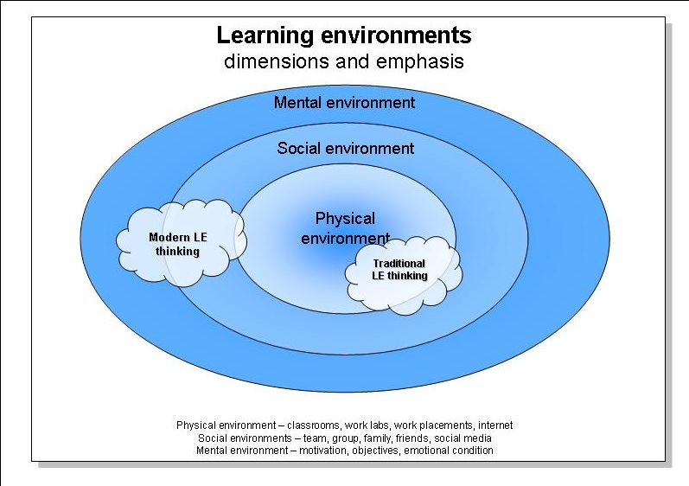
Here the perspective is more on the environment itself and its different conditions.

The traditional learning environment thinking is focused on the physical environment with slight reflections towards social environment whereas in the more modern approach the focus is clearly in social environment leaning towards mental environments with only a very small reference to physical environment.

