Federal Republic of Germany (Bundesrepublik Deutschland)
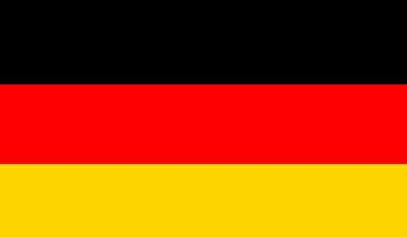
Flag
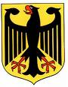Coat of arms

This guide will give you only some information about Germany. The web sites www.wikipedia.org and www.tatsachen-ueber-deutschland.de/en/, where you will find also more information.

1. General information
Capital: | Berlin
Official language: | German
Member state of … | EU (founding member), United Nations, NATO and G8
Area: | ~ 357,000 km²
Population: | ~ 82 million inhabitants
Currency: | Euro (€)
Time Zone | CET; Summer: CEST (Time in Finland – 1 hour = Time in Germany ☺)
Calling Code: | + 49

2. Administrative divisions
Germany is divided into 16 states (in German called Bundesländer or Länder). It is further divided into districts and cities.

3. Geography
Due to its central location Germany shares borders with more European countries than any other country in Europe.

It shares borders with Denmark in the North, Netherlands, Belgium, Luxembourg and France in the West, Switzerland and Austria in the South and the Czech Republic and Poland in the East.

The North Sea and the Baltic Sea represent also National Boarders in the North.

4. Climate
The greater part of Germany lies in the cool/temperate climatic zone which humid westerly winds predominate.

In the north-west and north the climate is oceanic and rain falls all year round. Winters there are relatively mild and summers tend do be comparatively cool, even temperatures can reach above 30 degrees Celsius.

In the east the climate is more continental. Winters can be very cold for long periods, while summers can be very warm, often with long dry periods.

In the central part and the south the climate varies from moderately oceanic to continental, always depending on the location. Hot summers with temperatures up to 30 degrees Celsius are also possible like long and cold winters with temperatures down to minus 20 degrees Celsius.

5. German language
The German language has its origin in Old High German which is related to old English.
Danish, Low German, Sorbian, Romany and Frisian are protected as minority languages.

There are a lot of different dialects of German, which are very different from standard German. Dialects are mostly spoken in Saxony, Bavaria, Rhineland-Palatinate and Swabia, but also in Berlin, Hamburg or Cologne.

Some people say that they speak without any dialect. Nevertheless, most of them use often single words, which are different form standard German. Anyway, do not be afraid!

If you want to improve your language skills, use www.bbc.co.uk/languages.

Please note: There is a difference in quoting the time between eastern and western Germany!
Time | English | Western Germany | Eastern Germany
16:15 | quarter past four | viertel nach Vier | viertel Fünf
16:45 | quarter to five | viertel vor Fünf | dreiviertel Fünf
16:20 | 20 (minutes) past four | 20 (Minuten) nach Vier | 10 (Minuten) vor halb Fünf
16:40 | 20 (minutes) to five | 20 (MInuten) vor Vier | 10 (Minuten) nach halb Fünf

6. Religion
About 70% of Germans are religious and 30% are Non-religious.

Most of the religious Germans belong either to the Protestant (33%) or to the Catholic (32%) church. The remaining people are members of the Orthodox Church, Islam, Buddhism, Judaism and other religions.

7. Holidays
There are nine public holidays, which are hold all over Germany:

New Year’s Day | January 1
Good Friday | Easter Sunday - 2 days
Easter Monday | Easter Sunday + 1 day
Labour Day | May 1
Ascension Day | Easter Sunday + 39 days
Whitmonday | Easter Sunday + 50 days
Day of German Unity | October 3
Christmas Day | December 25
St. Stephen’s Day | December 26

Public holidays, which are hold only in some federal states:

Epiphany Day | January 6
Corpus Christi | Easter Sunday + 60 Days | in federal states with strong catholic tradition
Assumption Day | August 15 | only in Bavaria and Saarland
Reformation Day | October 31 | only in the 5 federal states of former GDR
All Saints Day | November 1 | in federal states with strong catholic tradition
Penance Day | Wednesday before November 23 | only in Saxony

8. Main differences compared to Finland
“Du” or “Sie”?
Never ever address a stranger, your boss and your colleges with ”Du” or his/her first name.. That is impolite. Use always ”Sie” and the sure name. Use ”Du” only when you talk to friends or relatives.

In Germany you will not distinguish between Miss, Mrs and Ms. It is always Frau.
(Miss Webster, Mrs Webster, Ms Webster = Frau Webster)

Punctuality
Germans do not like to wait! So be always punctually, particularly in businness life.
A delay up to 15 minutes is OK when you can excuse that (you missed the tram, the bus was to late …).

Dinner or supper?
Germans do not distinguish between dinner and supper. It is always Abendessen or Abendbrot. Time for supper is 5 pm or later.

Opening hours of stores
The most stores and shop open between 9 and 10 am and close between 6 and 8 pm. It depends on what kind of store it is (small shop, big store or shopping centre) and on the region you live in. Supermarkets often work from 7 am to 8 pm.

On Sundays all shops are closed. It could be that during Christmas time some shops and stores are also open on Sundays.

Films
Films in Germany are always synchronised and have no subtitles. You can switch the languages only on a DVD.

Prices
Food and drinks like dairy products, cookies, bread and meat are normally cheaper than in Finland (especially when you buy the supermarkets own brands).

Prices for Public transport vary from region to region and town to town. In a big city it is more expensive than in a small one. Ask for students and group discounts.

To go buy train is quite expensive. A single one-way train ticket from Munich to Hamburg costs about 100 € when you use ICE (the fastest train in Germany). As student discounts are not granted, ask always for group discounts or special offers like Summer or Winter special (29 €/one-way ticket throughout Germany).

Prices for clothing are similar to Finland. Most famous and known throughout Germany are Karstadt, H&M, C&A …

9. Customs
Carnival
The tradition of Carnival is different in many regions. The most famous feasts are the Carnival feasts in the Rhineland. For more information use:
www.german-embassy.org.uk/Carnival.html

Easter
In the most regions Easter starts with Good Friday (Karfreitag). In some regions you are not allowed to make any loud noises, why there it is also called Silent Friday (Stiller Freitag). Many families eat fish instead of eggs and meat on Good Friday.

Almost everywhere in Germany eggs are coloured in different ways - boiled ones for decorating the breakfast table on Easter Sunday, blown ones for the Easter tree.

For almost all children Easter Sunday starts with going out and hunting for Easter eggs, sweets and small present, which were brought by the Easter Hare.

In the northern and western part of Germany people celebrate Easter with an Easter Fire. In northern Germany the fire is lit on Saturday evening, in western Germany either on Easter Sunday evening or Easter Monday evening.

St. Nicolas
On December 6 is St. Nicolas Day. On the evening before the children polish their shoes and boats. The shoes and boots are filled with small gifts and sweets by St. Nicolas during the night. Children, who have not polished their shoes, get either piece of coal etc.

Advent season
The Christmas season starts at the beginning of Advent, which is four Sundays before Christmas Eve.

Most families decorate their houses and flats with Advent and Christmas decoration. The most common are small figures, stars, candles and an Advent wreath, but it also varies from the region you stay in. Children often get a Advent calendar to count the days up to Christmas.

In Bavaria people also use small figures and pictures of Holy Maria, Joseph and Jesus. In eastern Germany families decorate with Moravian Herrnhut Advent and Christmas Stars (Herrnhuter Advents- und Weihnachtssterne), Räuchermännchen (a wooden figurine in which you can insert and burn incense and then they “smoke”) and Light arches (Schwibbogen) from the Ore Mountains.

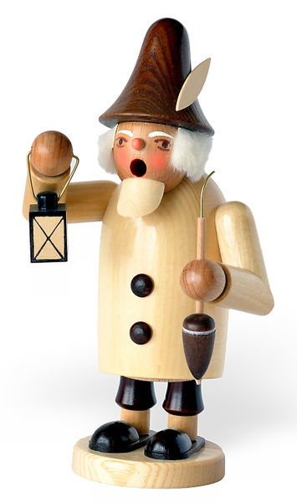
”Räuchermännchen“
by Andre Karwath
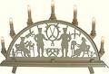
”Schwibbogen”
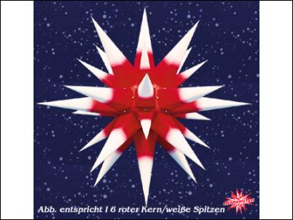
Moravian Herrnhut Advent and Christmas Star
www.moravian-stars.com

During Advent season there are a lot of Christmas markets (also called: Christkindl market) throughout Germany. The most famous ones take place in Dresden (Striezelmarkt), Stuttgart and Nuremberg.

At these markets you can enjoy Christmas cookies from Lebkuchen (small gingerbreads) to Stollen (fruit bread). If you feel cold you can drink Glühwein, a hot mulled wine.

Use www.wikipedia.org and insert Stollen, Lebkuchen, Christmas market, Striezelmarkt for more information

Christmas
German children get their presents on the evening of December 24, Christmas Eve, after the dinner. In many families either Father Christmas (Weihnachtsmann) or the Christ Child (Christkind) visits the children. Both put the presents under the Christmas tree.

A lot of families also go to church on Christmas Eve. Services could be in the afternoon or in the late evening.

On Christmas Day and St. Stephen’s Day family members often meet each other at the house of the grandparents.

